Devin Hardy

00076619

[Dhardy2@my.athens.edu](mailto:Dhardy2@my.athens.edu)

1.

a. <https://www.bk.com/menu/section-section_5596>

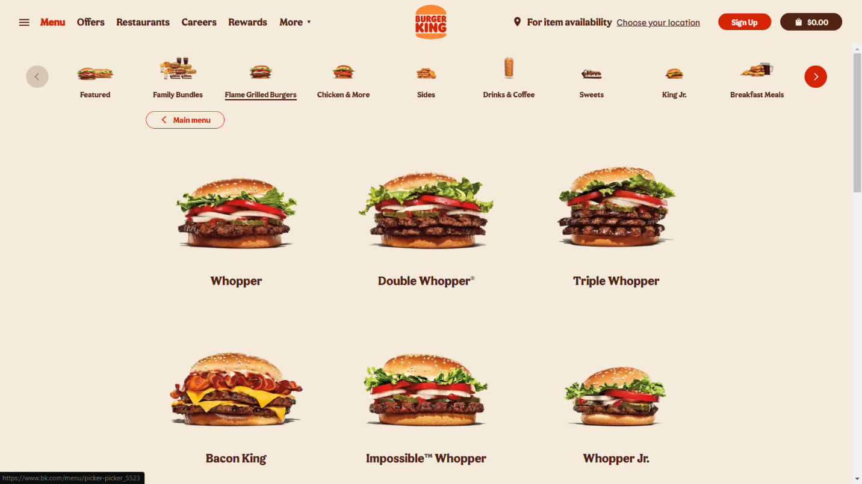

Info images convey about the site

It displays the food they serve and provides the ability to click on the image to know more about the food. It conveys that they are a business that serves food and shows the menu that is available if you ever decide to visit any one of their stores to get food.

How it appeals to visitors

It appeals to visitors so that they can see what they might want before they ever visit one of the stores. Might also make the visitors hungry so that they are more likely to visit.

b. [https://whnt.com/weathe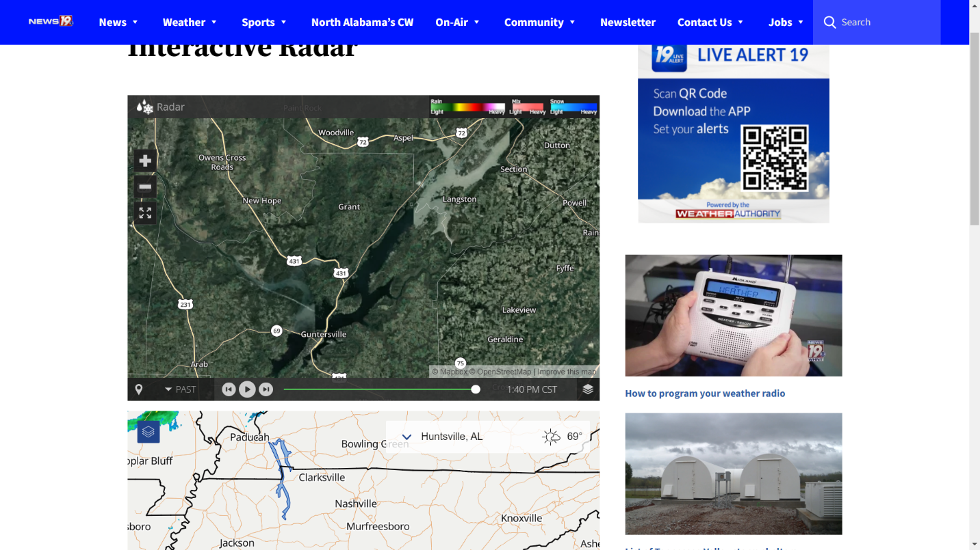r/maps-and-radar/interactive-radar/](https://whnt.com/weather/maps-and-radar/interactive-radar/)

Is the map Interactive?

Yes, the map is interactive.

Does it properly show the location?

It does properly show the location. So much so that you know what weather you will get.

c. <https://techguided.com/budget-gaming-pcs/#3>



Can return to the main list?

You can but must scroll all the way to the top to get to it again.

How are you able to access other sections of the list?

The bookmarks link to different portions of the same site. So to access those parts you can just keep scrolling down or reading to get to them.

d. <https://www.scribbr.com/citation/generator/>

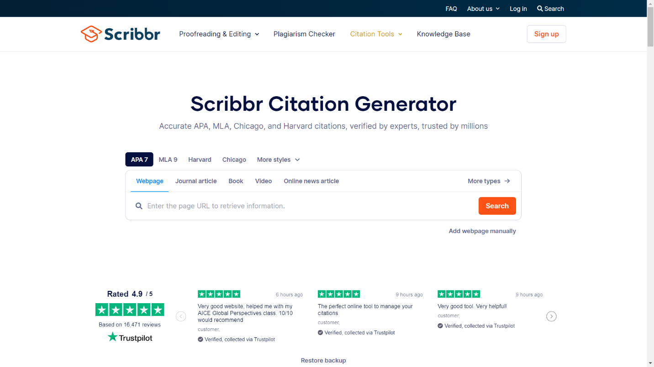

Is it Get or Post?

I believe it to be get

Best suited for storing information or can the info me emailed?

For storing quick information.

e. <https://www.avast.com/en-us/lp-ppc-free-antivirus-brand-a1?ppc_code=013&ppc=a&gclid=bca4d5c5005f190f295fb627a7946749&gclsrc=3p.ds&msclkid=bca4d5c5005f190f295fb627a7946749&utm_source=bing&utm_medium=cpc&utm_campaign=en-us_ava_sch_brn_exc_bng_dtp&utm_term=avast&utm_content=top-avast-exact#pc>

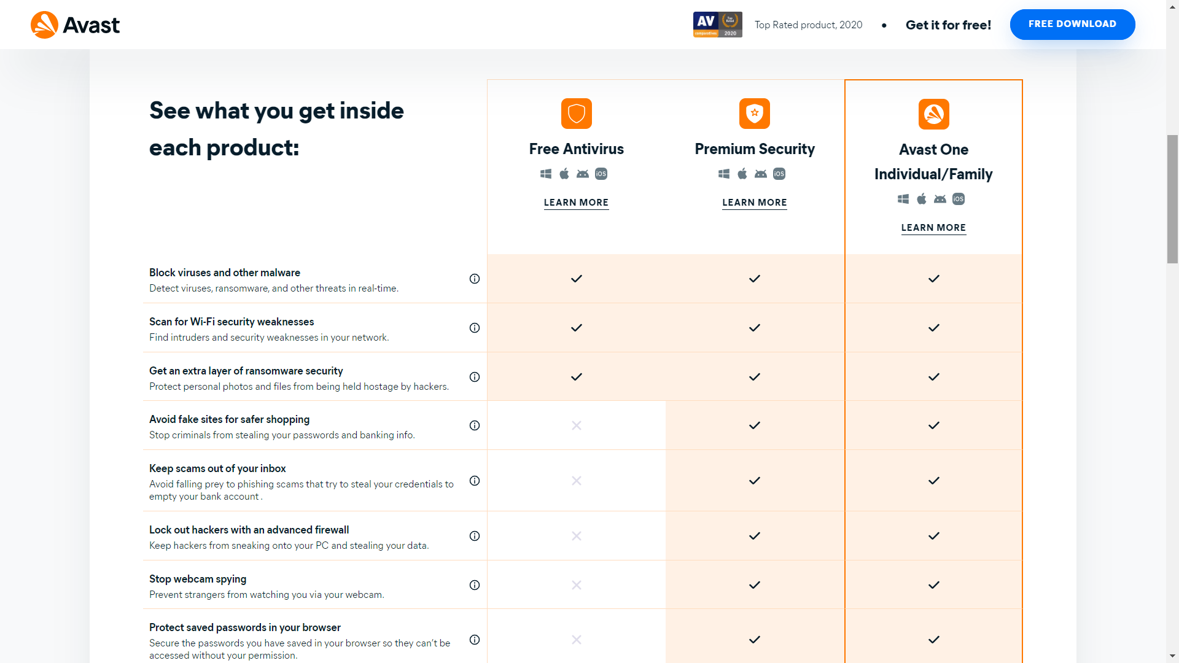

Is it being structured appropriately?

It is structured appropriately.

What info is it conveying?

It is displaying what versions of the application holds specific types of abilities.

Is a table the best way to convey this?

Yes I think it is a great way to convey this info.

2.

3.

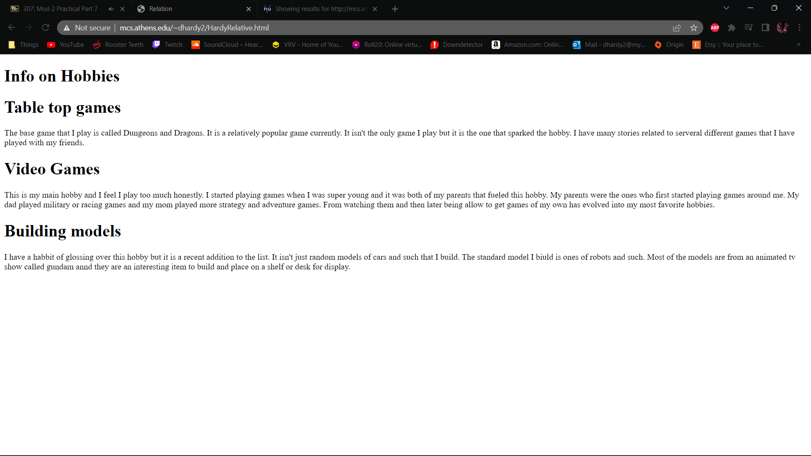

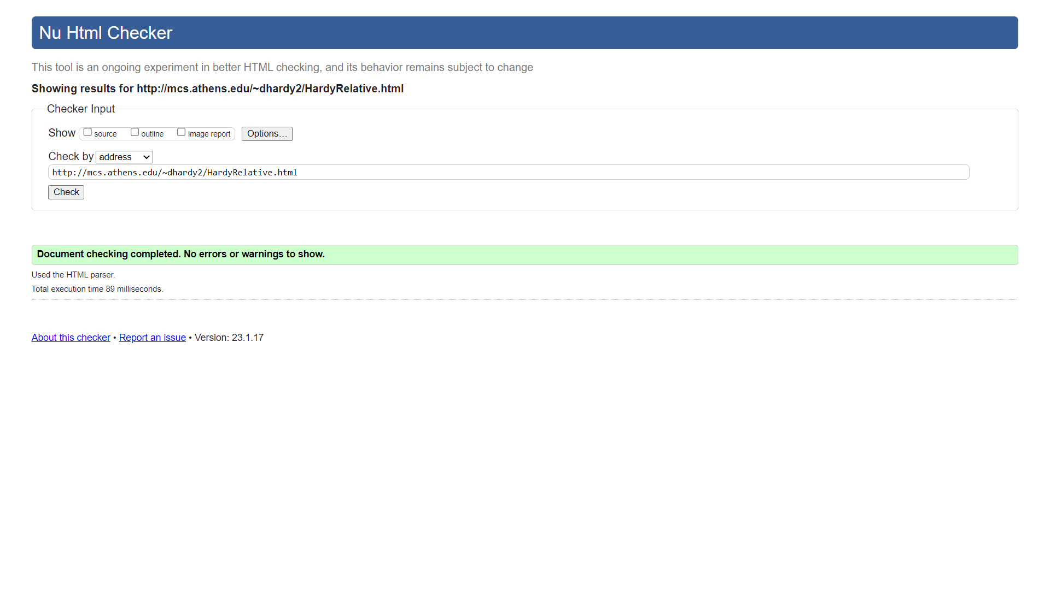

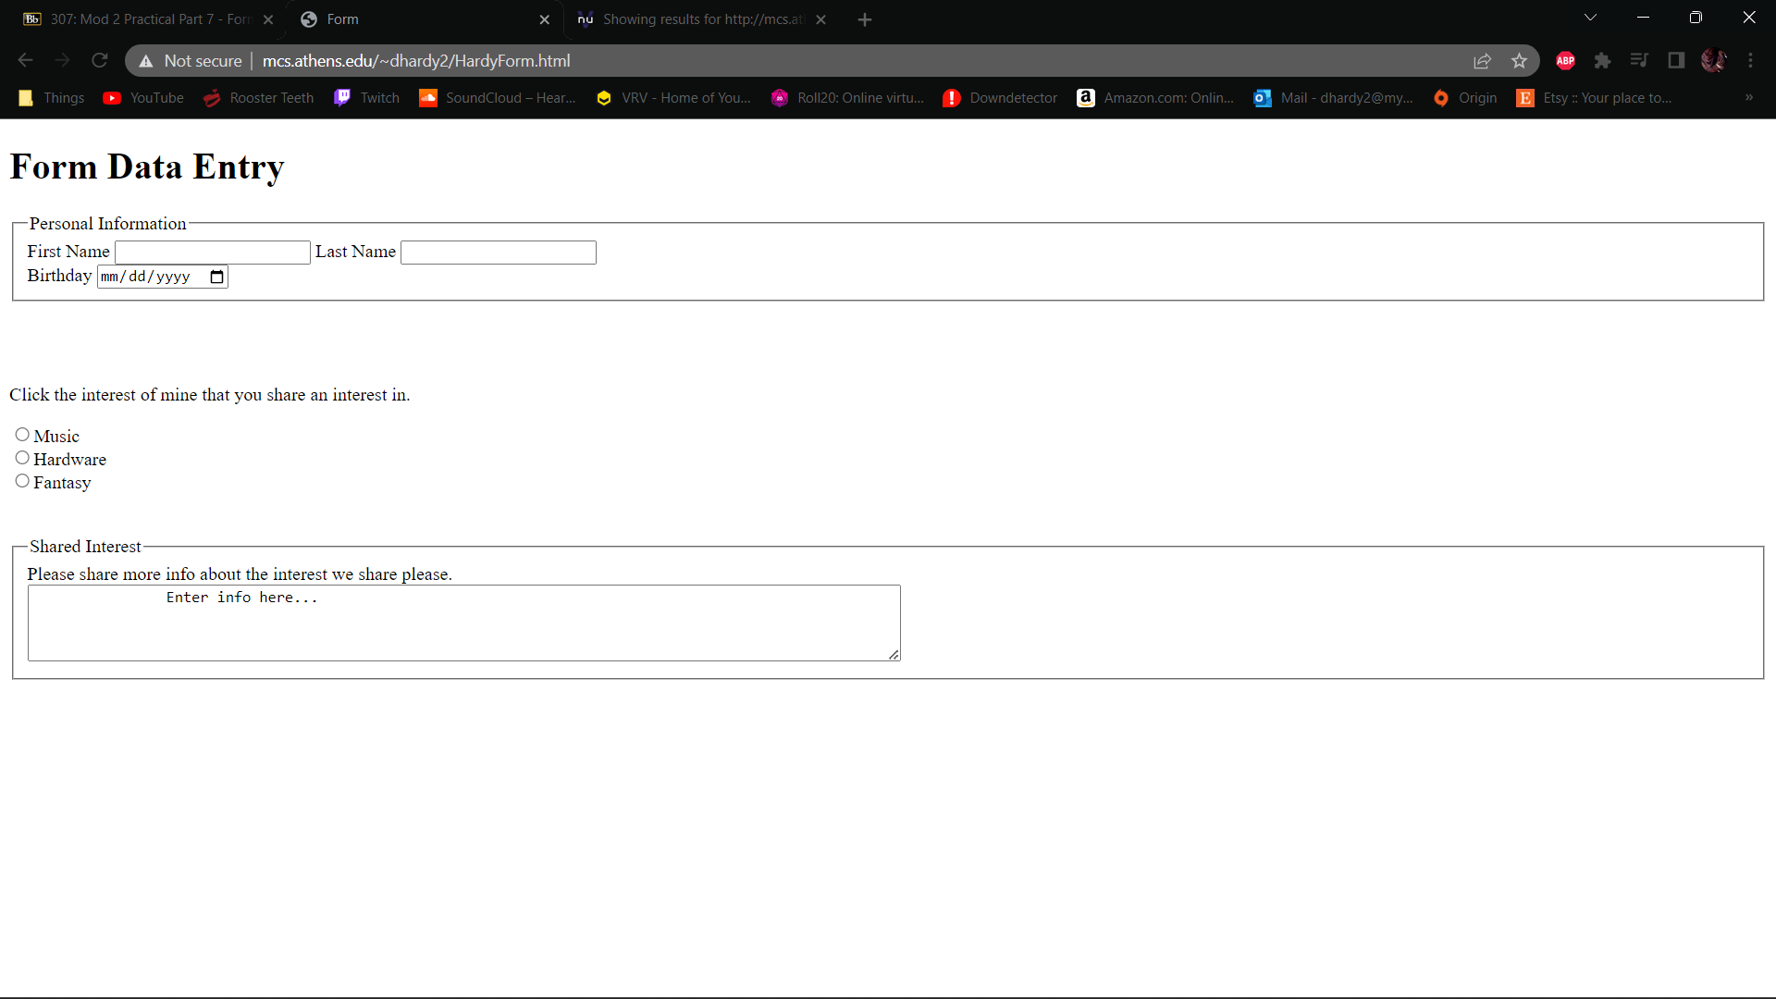

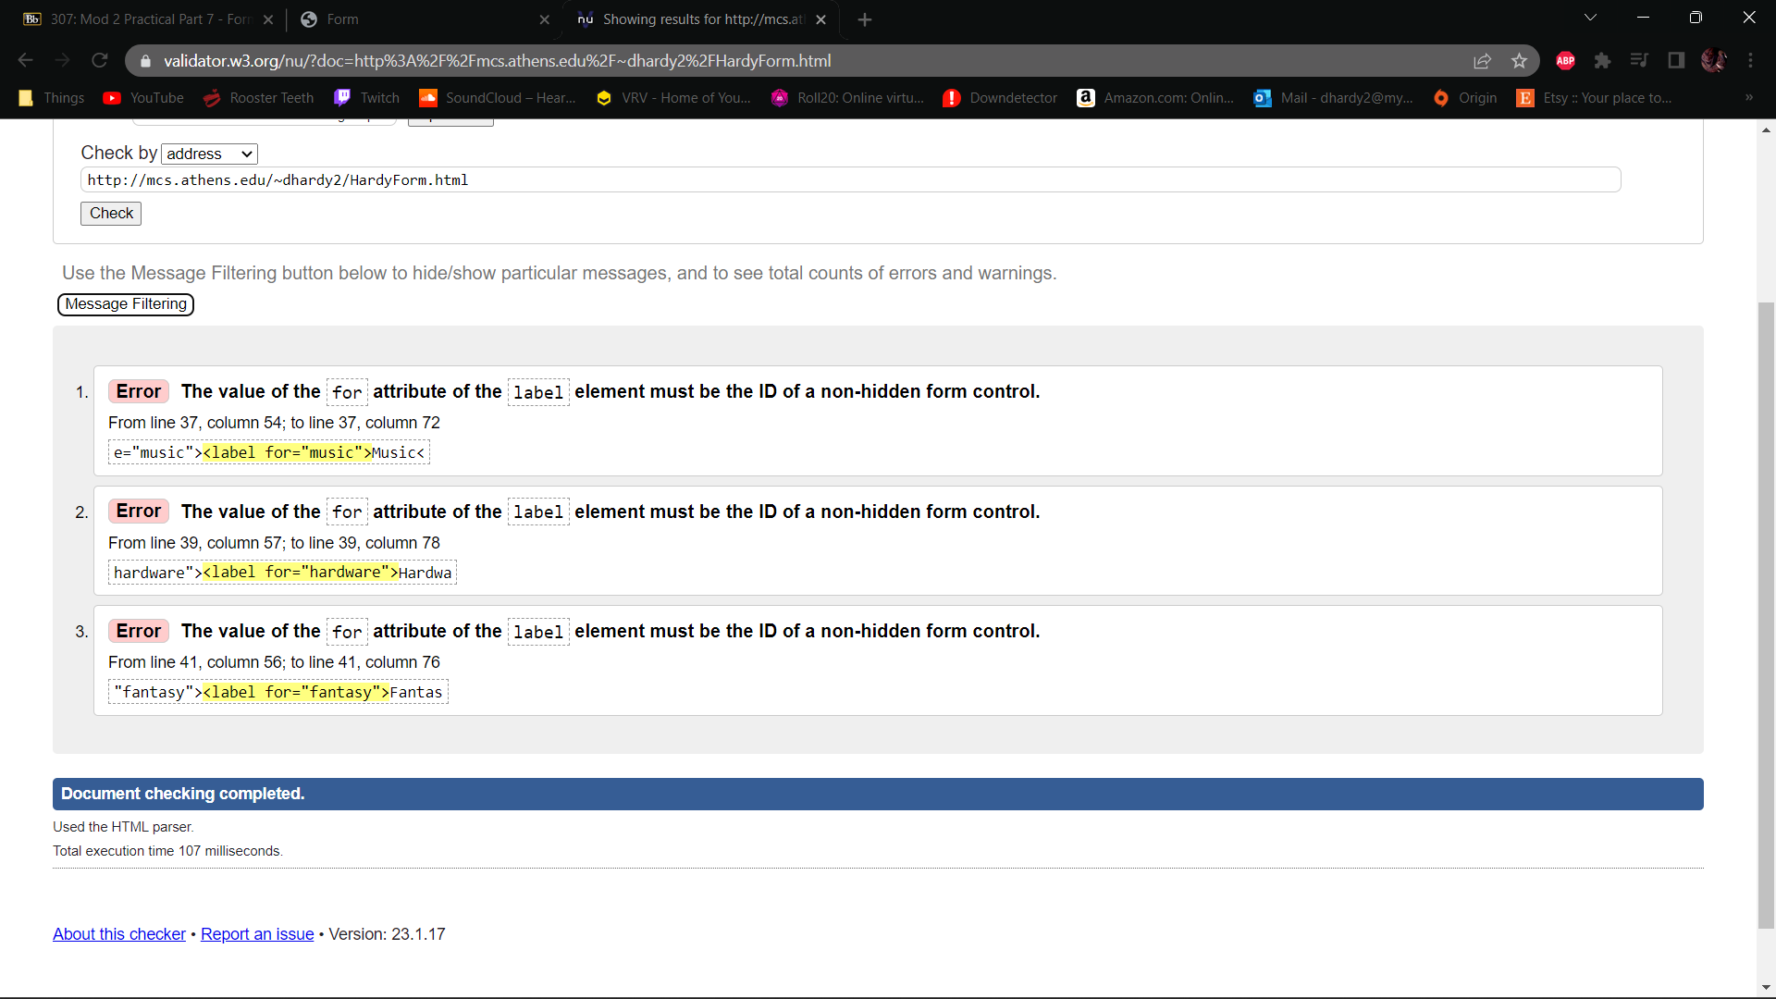

4. Build off of the pitch.

5.

